**S:\ICH\DBC_ImagingFacility\Teaching Courses\ImageJ-Fiji Course\Course Logo\ImageJ Course Logo4 for word doc.tif**

**Exercises Day 1 Image analysis with ImageJ / Fiji**

**Exercise 1) Images are just numbers**

Open the sample image Blobs

File / Open Samples… / Blobs (25K). If you’ve got no internet it is also in the course files ‘Fiji Sample Images’ folder.

File / Save as > text image…

Drag the .txt file to imagej

Make the original Blobs image binary (Process / Binary > Make Binary)

File / Save as > text image… call it blobsBinary.txt

Drag the blobsBinary.txt file to imagej

Why are the two text files different?

Import both text files as image files (File / Import > Text Image…)

Why are the images the wrong way around? (white and black are reversed)

**Exercise 2) Bit depth display and Image Histogram**

Open Dapi\_WhatBitDepth.tif in Images for users / Exercise Images.

Open the image Histogram ( / Histogram – or Ctrl H). Press Log.

Open a second histogram window. Press Log and Live.

What is the likely bit depth? (8 bit 0-255, 12 bit 0-4095, 16 bit 0-65535)

Set the display range to the correct bit depth (Image / Adjust / Brightness/Contrast…)

You can press Auto, or Reset, or Press SET, then in the ‘unsigned 16-bit range:’ drop menu choose the correct bit depth.

How has the histogram window changed?

Set the 16-bit range to 16 bit.

Where did the image go?

**Exercise 3) Changing bit depth.**

Open Hela-Cells (from Fiji File menu, Open Sample images, or from Exercise Images).

Read the Information, do the Channel manipulations as described.

Re-open the original image, then remove the overlay.

Open Brightness and Contrast window, set Unsigned 16-bit range to auto.

Duplicate Channel 1 (Shift D) specify channel 1.

Duplicate again to have 2 red images.

Make one 8 bit (Image / Type > 8bit). Rename it “8-bit” (right click on Image)

Press H (Analyze / Histogram) for each red image. Press Log.

Note the histograms are basically the same, but one has 255 levels of brightness, the other 4095.

Use the Line tool to draw a line through the brightest red spot.

Press K (Analyze / Plot profile).

Activate the other red image, press Shift+E (Restore selection), press K.

Why are the graphs different? This bit depth change has lost data.

Repeat the duplication of the 16 bit red channel, then set the display range (in Brightness and contrast window, the SET button) to 12 bit. The image looks less bright (but the data in the image is unchanged, it is just displayed less brightly). Now make it 8 bit and plot the profile across the brightest red spot.

Why is the new profile no longer clipped? (Display is 8 bit, data is 12 bit, converting to 8 bit within ImageJ takes the values from the displayed image, not the underlying data.)

BE CAREFUL: Decreasing bit depth reduces image intensity detail, and may crop data.

**Exercise 4) Using the histogram and LUT to check image acquisition.**

Open image fluorescent cells.lsm (Exercise Images)

1) Press Ctrl+Shift+D. (Duplicate) 2) Image / Color > Split Channels

3) Image / Lookup Tables > HiLo. 4) Select each image, press H (Histogram)

5) Press Log. Press Live. 6) Press Ctrl+Shift+C. Adjust the image…

7) Image / Lookup Tables > Fire. 8) Adjust the image.

9) Image / Color > Edit LUT… You can assign any colour to any pixel value…

**Exercise 5) Make Image Montages for figures.**

Open image fluorescent cells.lsm (Exercise Images)

Make two montages:

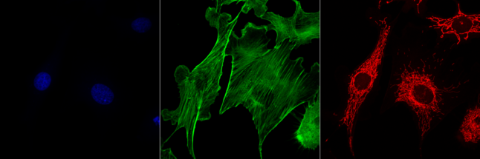

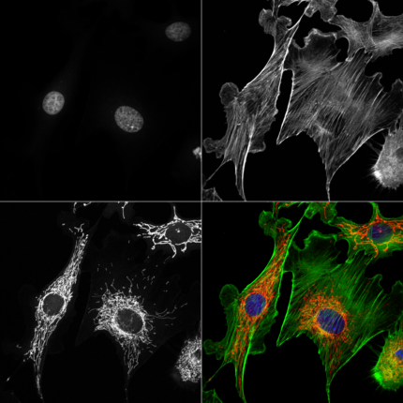

Hints:

Make Montage. Use a border. Make image grayscale using the channels tool. Make a composite of this with an empty quadrant, (2x2 montage). You’ll need to make an RGB colour image of the overlay picture. Also a Grayscale of the original stack before making the second montage.

I have written a macro to do this:

<https://www.ucl.ac.uk/child-health/core-scientific-facilities-centres/confocal-microscopy/advice-protocols/imagej-macros>

It can also be done in ICY.

**Exercise 6) Draw a teddy bear’s face on an image.**

Open Samples: FluorescentCells.tif

Use circle and polygon selection tools.

Hold shift to add to an ROI. Hold Alt to remove from an ROI.

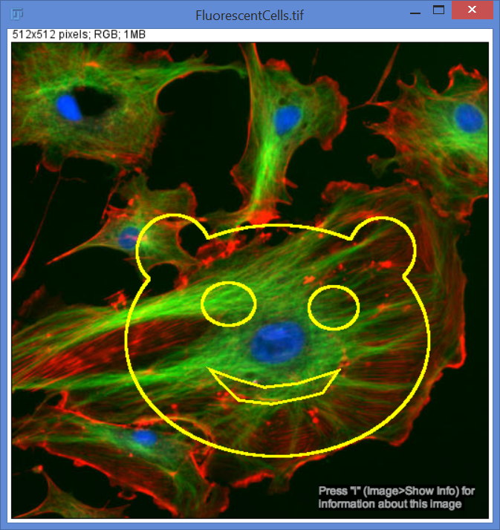

**Exercise 7) Measure Nuclei size and intensity in HelaCells.tif** (from Sample Images or Exercise 3)

Use magic wand to select each nuclei. (Select the wand, click on a nuclei then Double click on the Wand tool to change the tolerance)

Use ROI manager to save each nuclei ROI (press T).

Set measurements.

Measure the Nuclei.